TOPIC 2 - BRUTE FORCE

Q1. Selection Sort Implementation
Aim:
To sort an array in ascending order using the selection sort algorithm. Algorithm:
- Start from index 0.
- Find the smallest element in the unsorted portion.
- Swap it with the first unsorted element.
- Move the boundary rightwards.
- Repeat until fully sorted.
CODE:
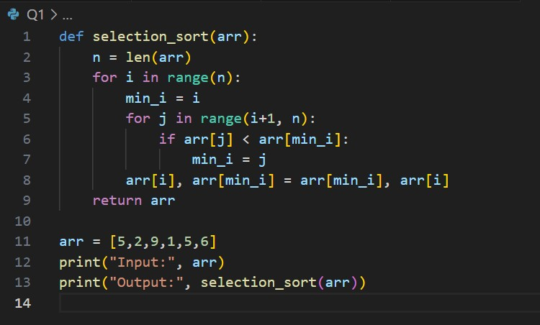

Input & Output
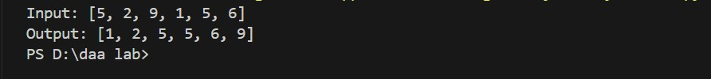

Result: Array sorted successfully using brute force selection sort.

Q2. Bubble Sort Optimization
Aim:
To implement bubble sort and stop early when the array becomes sorted. Algorithm:
- Traverse the array multiple times.
- Swap adjacent elements if out of order.
- Track if a swap occurred in the pass.
- Stop if no swaps occurred.
- Print sorted array.
CODE:
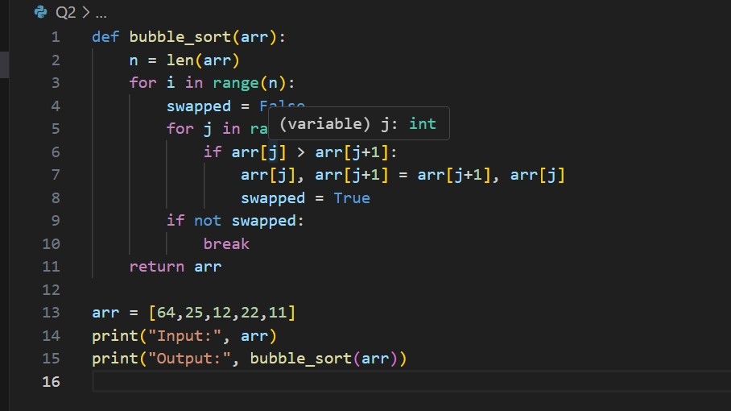

Input & Output:

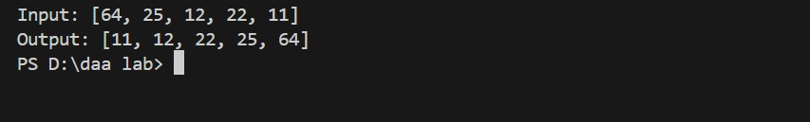

Result: Optimized bubble sort executes fewer passes.

Q3. Insertion Sort with Duplicates
Aim:
To sort an array with duplicate values while maintaining relative order. Algorithm:
- Iterate from index 1 to n − 1.
- Store current value in _{key}.
- Compare _{key} with previous elements.
- Shift elements greater than key.
- Insert _{key} in its correct position.
CODE:
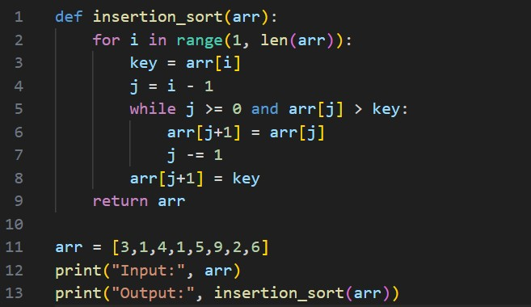
Input & Output:

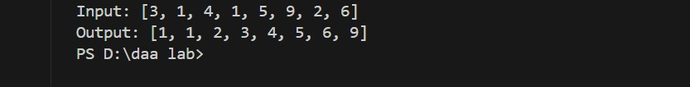

Result: Stable sort achieved with duplicates handled properly.

Q4. Missing Positive Number
Aim:
To find the k-th missing positive integer in a sorted list. Algorithm:
- Read sorted list and k.
- Generate missing numbers by comparison.
- Count until k-th missing number found.
- Return that number.
- End.
CODE:
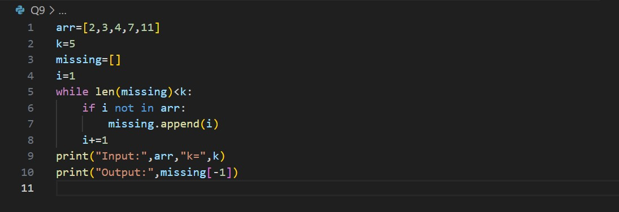

Input & Output:

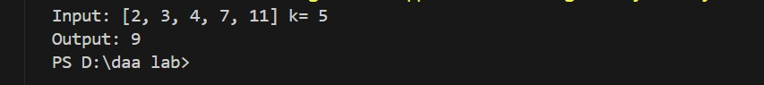

Result: Fifth missing integer correctly identified as 9.

Q5. Closest Pair of Points
Aim:
To find the closest pair of 2D points using brute force. Algorithm:
- Input list of points.
- Compute distance between every pair.
- Store minimum distance and pair.
- Compare all pairs.
- Output closest pair.
CODE:
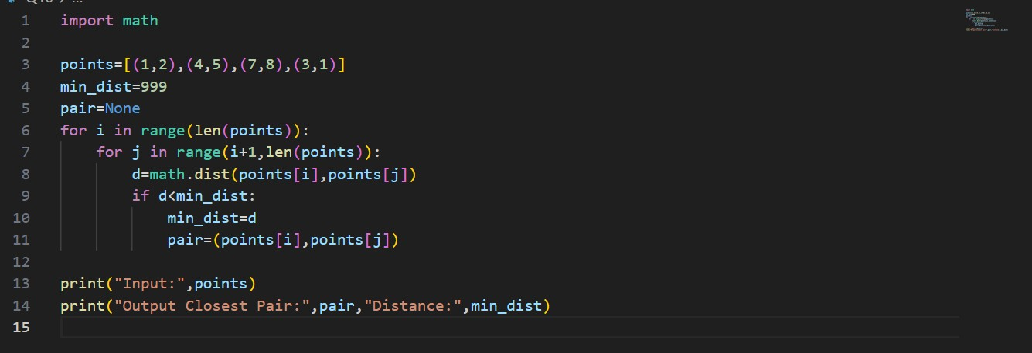

Input & Output:

Result: Brute-force method finds correct closest pair.

